EFITM One PLC
NTP Server Configuration. Press and PLC

EFI ONE PLC
What’s inside:

Introduction 3
Scope 3
How To Configure Server in Press PC 3
Enabling the NTP Server 3
Update the configuration of the NTP Server 3
Restart the Service 4
Configure the service to automatic start 5
How to Configure NTP Client in PLC 6
Overview 6
Variables 6
Status 6

Introduction
Scope
The goal is automatically update PLC time with the time in the Press PC. For this a NTP server will be used.
The Press PC will be the NTP server, and the PLC will be the client taking the proper time from the Press PC.

How To Configure Server in Press PC
Setting the Config of the NTP Server
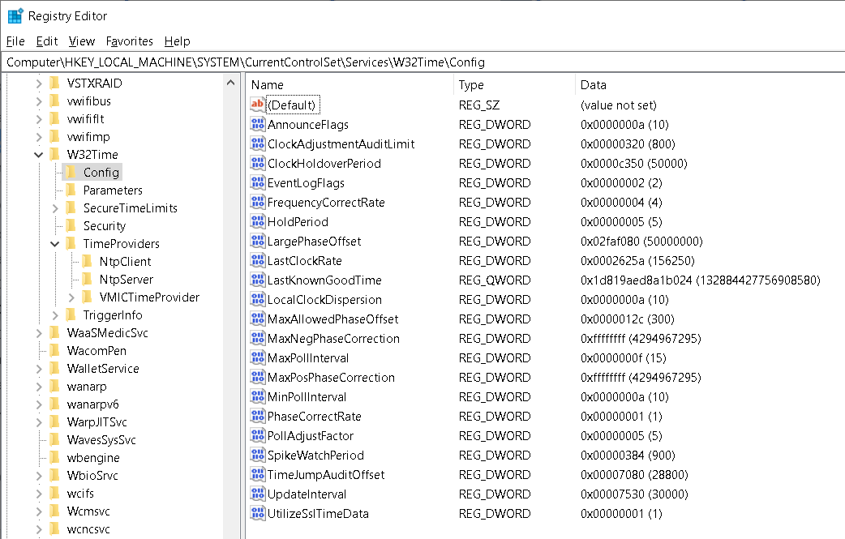
Enabling the NTP server service requires a quick registry modification. Open Regedit and navigate to HKEY_LOCAL_MACHINE \ System \ CurrentControlSet \ Services \ W32Time \ Config. Review this list of fields

Setting the Parameters of the NTP Server
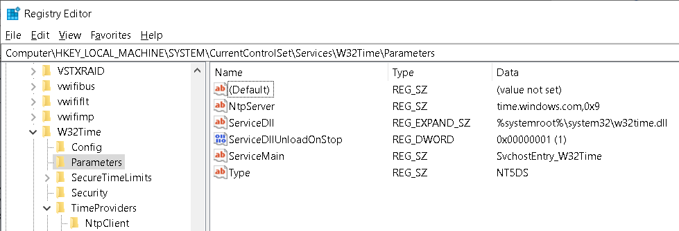
Enabling the NTP server service requires a quick registry modification. Open Regedit and navigate to HKEY_LOCAL_MACHINE \ System \ CurrentControlSet \ Services \ W32Time \ Parameters. Review this list of parameters

Enabling the NTP Server
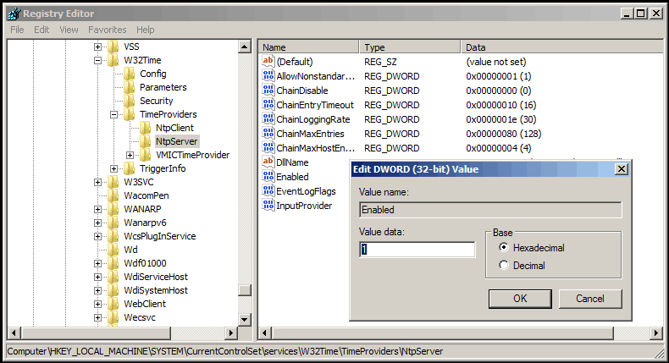
Enabling the NTP server service requires a quick registry modification. Open Regedit and navigate to HKEY_LOCAL_MACHINE \ System \ CurrentControlSet \ Services \ W32Time \ TimeProviders \ NtpServer and change Enabled from 0 to 1.

Update the configuration of the NTP Server
The last step is to update the Windows Time service’s running configuration. You do this by opening a command prompt and typing the w32tm /config /update command. You can then verify that the NTP server service is enabled with the w32tm /query /configuration command. Both of these are shown in Figure 4.
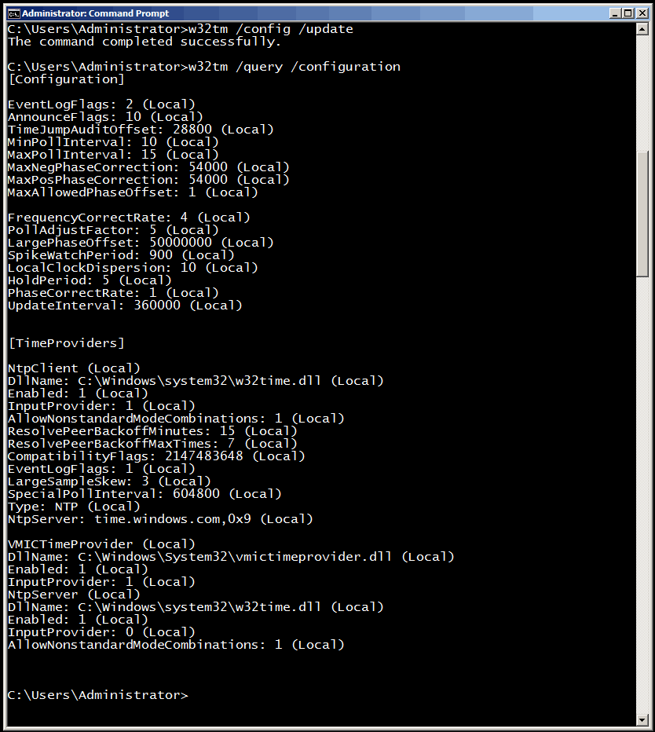
Restart the Service
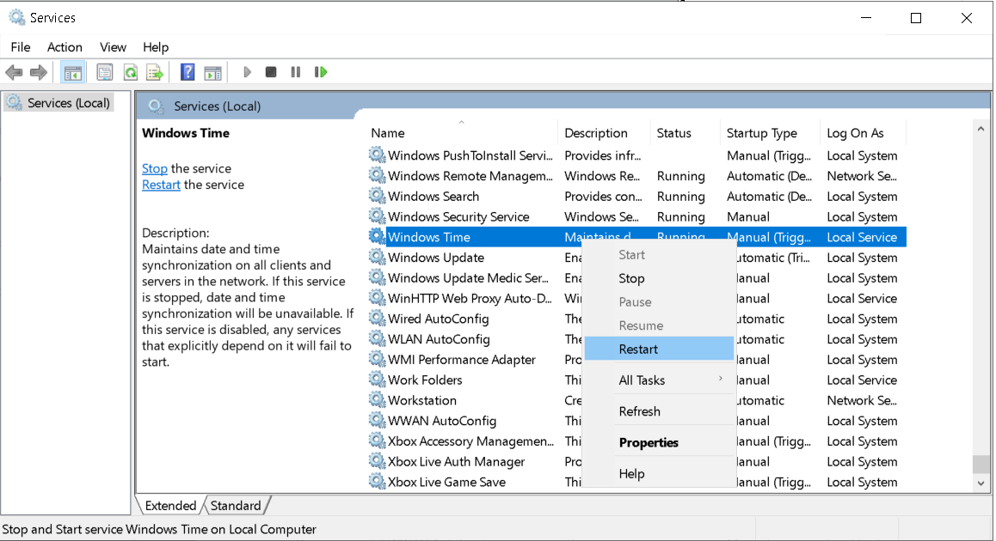
RestartStop the Windows Time service to configure it without problems

Configure the service to automatic start
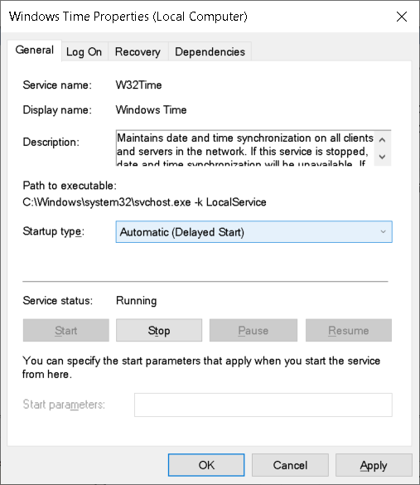
Supports all network printers running Windows drivers.

How to Configure NTP Client in PLC
Overview
The NTP Client in the PLC will act the same as whichever client in a computer. The only configuration needed is Time Zone and if there are day lights saving enabled or not.
Variables
The variables with the parameters to configure the client are:
Variable | Type | Explanation
TimeUTCTimeZone  gTime.Params.UTCTimeZone | Integer | UTC Zone in format 100 x Hours + Minutes  For Instance,  Location Code  Spain 100  Newfoundland -330  Kathmandu +545
TimeDaylightSavings  gTime.Params.DayLightSavingsTime | Boolean/Command | Variable to define if Daylight savings time is enabled in the location

Status
The variables with the status of the client are:
Variable | Type | Explanation
TimeState  gTime.Status.SwState | Integer | UTC Zone in format 100 x Hours + Minutes  For Instance,  Value Code  0 TIME_NOT_INITIALIZED  1 TIME_SETTING_TIMEZONE  2 TIME_SETTING_CLIENT  3 TIME_GETTING_TIMEDATA  4 TIME_RECEIVING_DATA  5 TIME_IDLE
TimeUpdated  gTime. Status. TimeUpdated | Boolean | Time updated by the NTP Server

